1a.  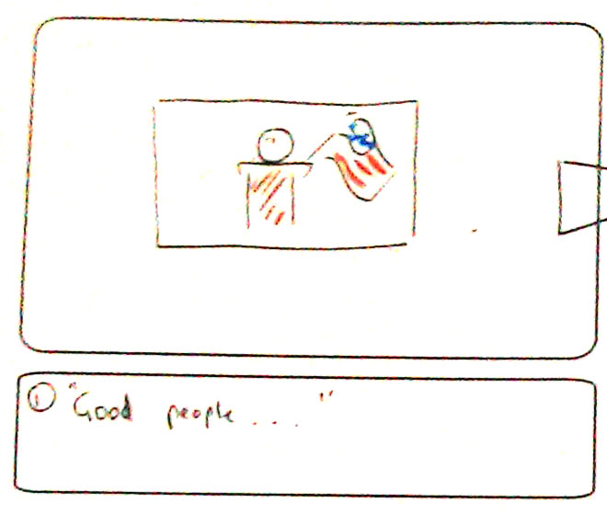  interaction: nothing  graphics: video / image of(Obama?) at presidential podium with flags behind  sound: audio of (Obama?) speaking | 1b. Good people of [BEEEP].  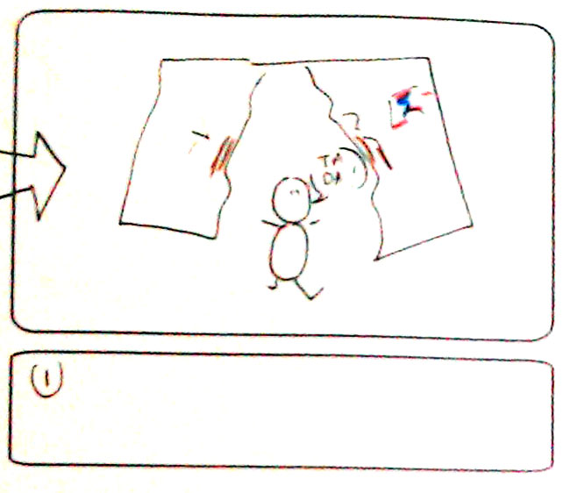  interaction: speaker burst through image from behind, ripping it in 2  graphics: flag ripping / shattering  sound - censor beep, smash/video | 2. I know I promised you to fix the economy  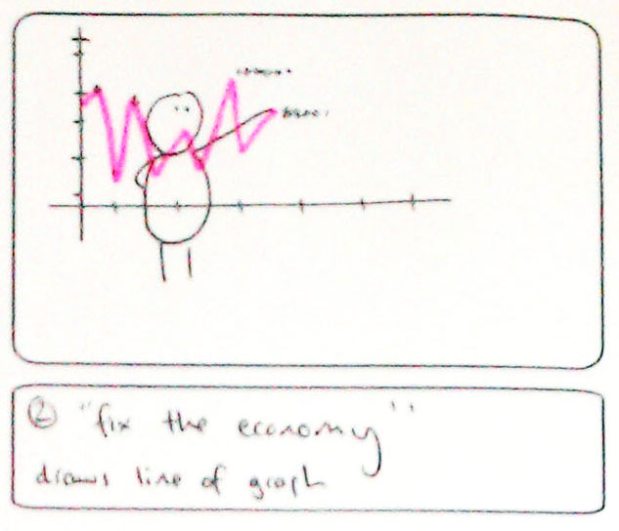  interaction: pointing finger draws graph line, pound sign particles  graphics: pound sign  sound: chalk on blackboard/squeeky whiteboard noise)
3. and give tramps work  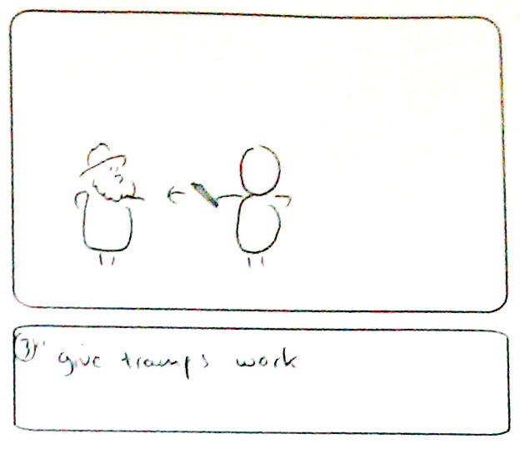  interaction: Lorna enters scene with tramp costume superimposed. speaker hands some kind of object representing work  graphics: tramp cutout, some kind of object representing work - £ sign  sound: kerching | 4. and save precious cats from trees.  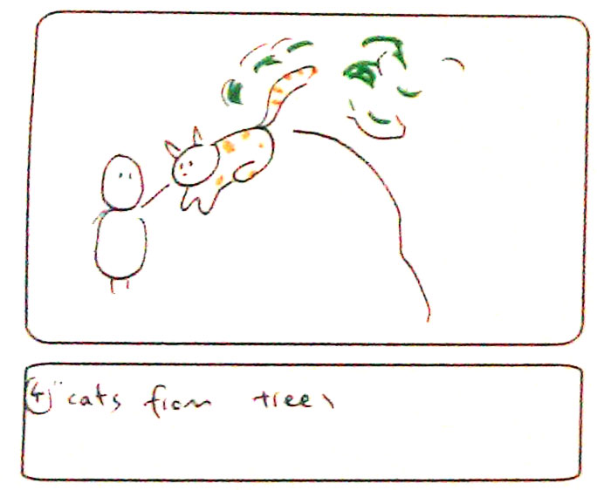  interaction: speaker stretches both arms and cat flies from trees  graphics: tree, cat  sound: meow | 5. But, I lied.  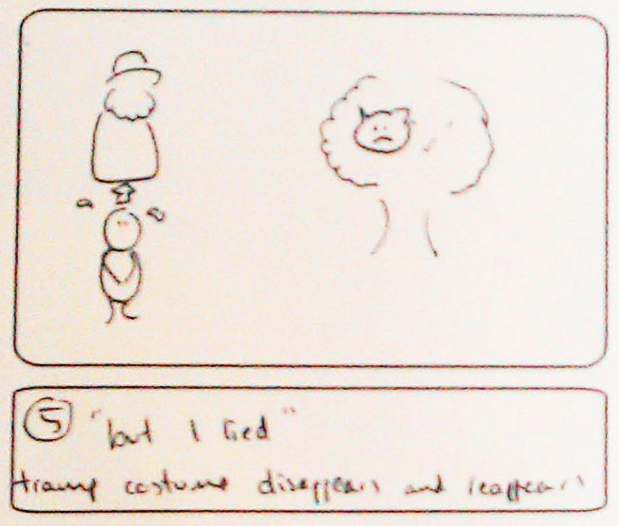  interaction: tramp costume disappears and re-appears and cat flies back into tree  graphics: same cat, tree and tramp  sound: music starts
6. This is my country, and my rules.  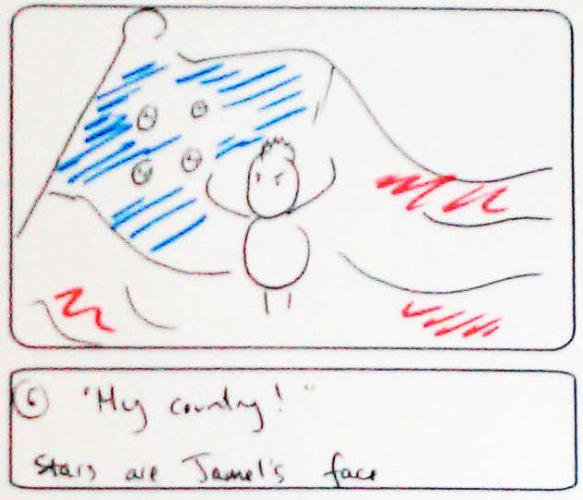  interaction: nothing  graphics: flag in background,, zoom into face?  sound: music | 7. No new hair styles, no new clothes, no end to the recession.  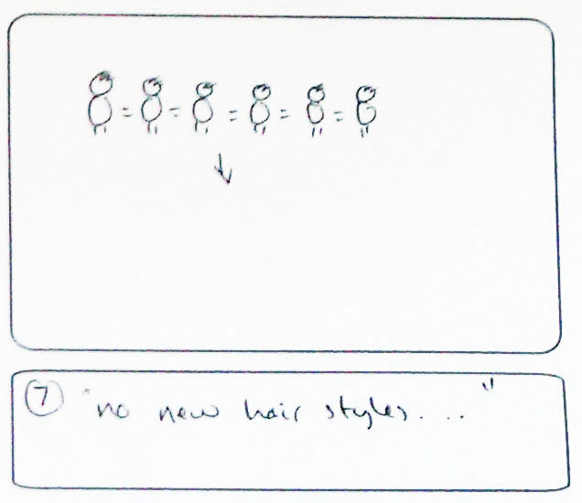  interaction: nothing  graphics: a group of people have the same hair style superimposed (all images of the speaker?), funky hairstyles replaced by boring hairstyles  sound: music | 8. Don’t think of running to the police or fleeing the country because you won’t be able to.  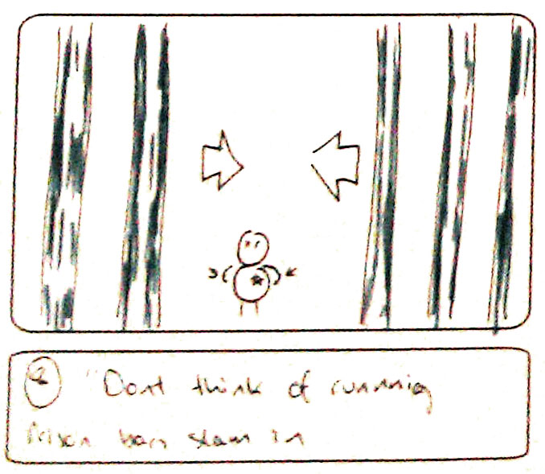  interaction: hands spread and then drawn into centre slam prison bars across frame  graphics: prison bars  sound: metal clang
9. No marriage for gays, hell lets even say no dating for em. No trips to the moon or visiting foreign websites.  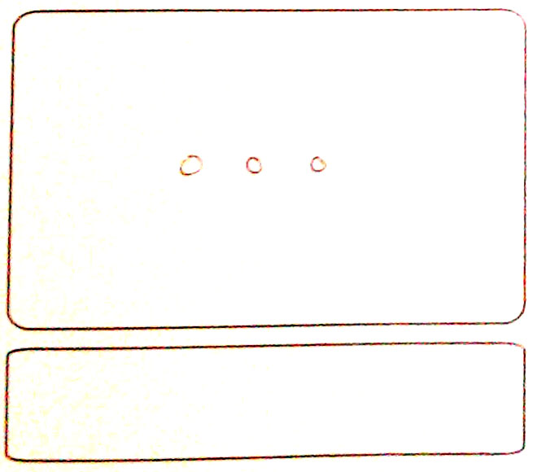 | 10. I am here to stay, not just for 8 years or whatever no, forever.  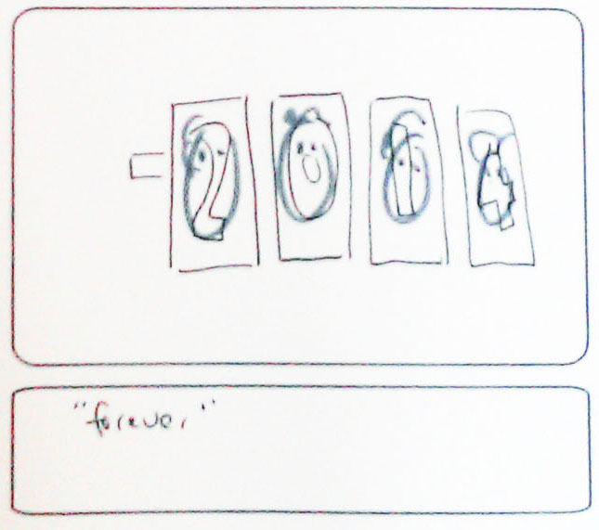  interaction: nothing  graphics: a flip style calendar counts upwards with speakers face on each digit. digits 0-9 with Jamel's face in them  sound: flicking of pages, forever - echo | 11. Selected by people you’ve never heard about, I am here. Welcome to BEEP,  welcome to me!  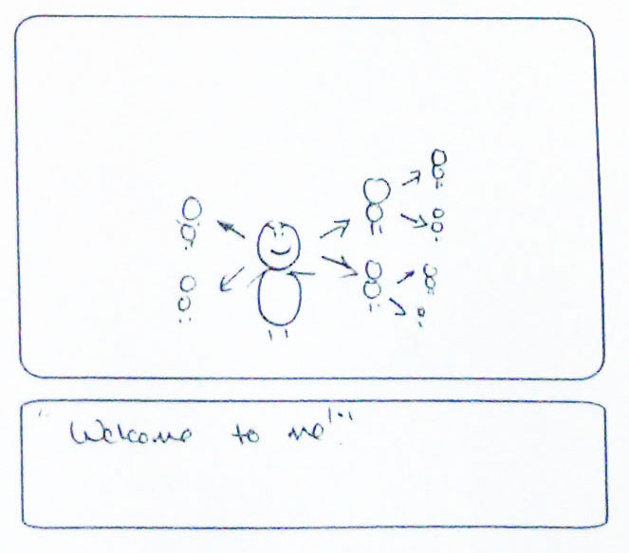  interaction: nothing  graphics: Jamel replicates and sub-replicates himself.  sound - pop for replicating

